Exercise 12 - Maze

Difficulty level: 3 out of 5

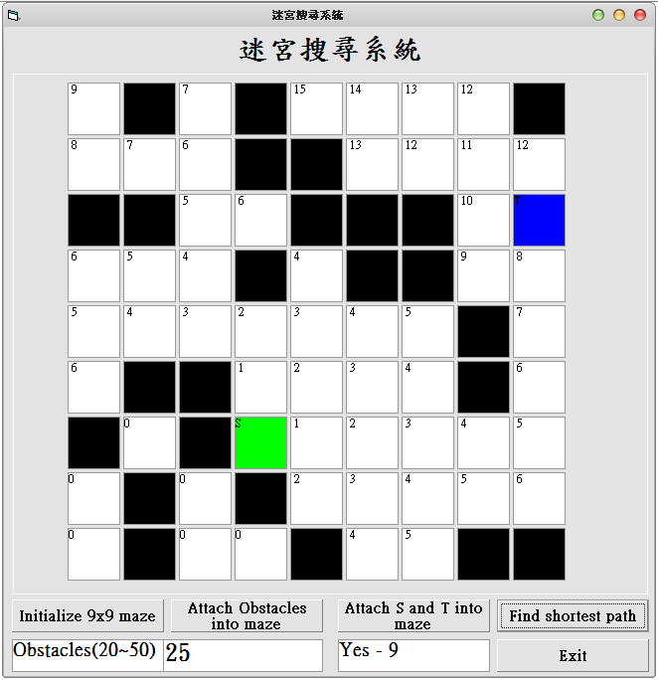

Let’s say the above is that maze that the “mouse” is trying to find its way through. The mouse wants to get from the start point (the blue box) to the end point (the green box) while navigating through the barriers (the black boxes).

Basically, the user will input the numbers below for the maze above or you can read it from a file.

101011110

111001111

001100012

111010011

111111101

100111101

010311111

101011111

101101100

Here’s what each of the numbers mean:

0 = Blocked (Black Box) – Mouse can’t move there

1 = Not Blocked (White Box) – Mouse can move there

2 = Start Point (Blue Box) – Mouse starts in this position

3 = End Point (Green Box) – Mouse ends in this position

X = Path mouse took

Basically for the output, you want to use ‘X’ for the path that the mouse took. Only replace 0 with X’s, don’t replace the numbers 2 and 3. For example:

101011110

111001111

001100012

11101001X

11111110X

10011110X

0103XXXXX

101011111

101101100

The mouse can only move up, down, left, or right. No diagonals.

The start and end point can be on any available white box.

Write a program that will solve a 9x9 maze with the instructions given above. The mouse doesn’t need to take the shortest path. It just has to take a valid path.

Optional: Find the shortest path that the mouse can take.